Project Report
Chaplin Cinelli
CS 480 Senior Project

Initial Project Summary

Design of program to study artificial life and its evolution. This includes taking morphology, behavior, and well-being of the life form, and using these properties to evolve the creatures that are randomly generated. The life form’s morphology will be limited to two-dimensional bodies consisting of abstract shapes. An example of how evolution will be shown is the relationship of morphology to energy retention and consumption. The program will be written in Java.

Stages of Design

The first part of the project was to design the shapes that would make up the morphology of the “creature.” The creature’s morphology consisted of several different shape components. The positioning was randomized, and was positioned so the shapes overlap or are cohesive. The importance of cohesiveness is tremendous; it would be similar to a human being born with a body and an arm, but not attached as they should. Once the individual components were written, the shapes came together in the body, (or the group of shapes as a whole,) and the morphology became visible.

Once the morphology was written, the basic crossover functions were written for each component, and the mutation function was written as a part of the crossover function.

Next, the area and half the area on both sides of the shapes and creature were measured and averaged. This average was used as the value for energy consumption. The area was used as the value for energy retention. The energy consumption is then averaged together with the energy retention to become the value for the energy fitness. This fitness is applied to the individual components of the body, and the body as a whole, with a higher fitness value meaning a more efficient component.

Then another fitness function was designed to make the morphology more cohesive, because sometimes the shapes would misalign randomly. This function was designed to eliminate random misalignments.

A random creature was then crossed over (a process analogous to breeding) with the best fitness found so far, and offspring are produced. After crossing over, the current best fitness in the “family” of creatures becomes the dominant best fitness, and this can continue indefinitely depending on the population size set.

Experimentation

Based on experimentation, a large population size is needed since much of the population will be rejected due to “deformities”-random misalignments removed by the morphological cohesiveness fitness function.

In the best fit creatures, individual shapes tend to be simpler in design.
In larger populations, either the larger and more spread out or smaller or more cohesive morphologies have the highest fitness.

The overall morphology of the best fit creatures seems to even out the total area of the shapes; the components are not excessively big or small, but evenly sized.

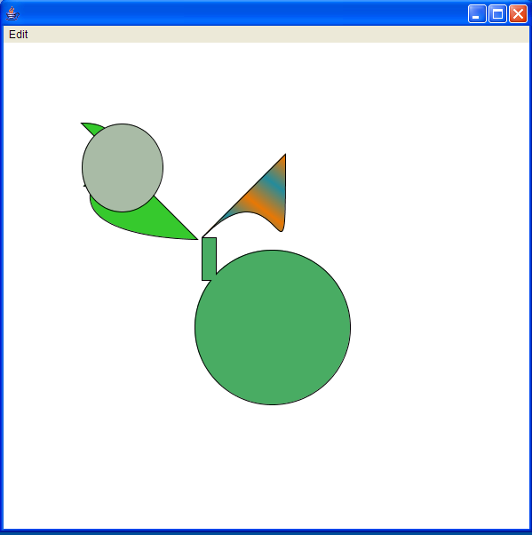
A creature without the energy and cohesive fitness function

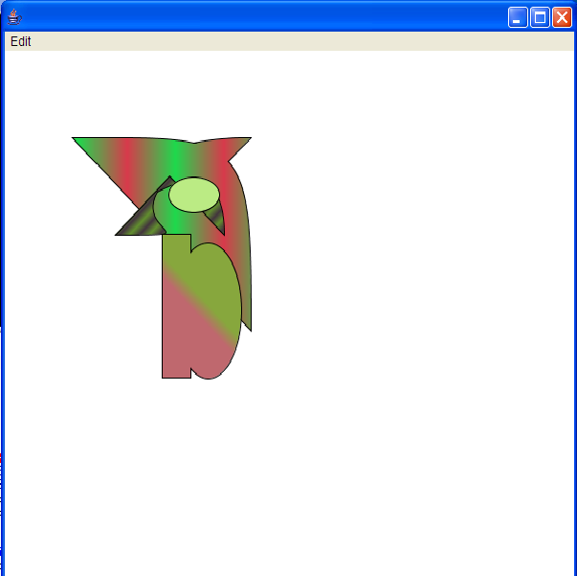
A creature with the energy, and cohesive fitness function

