Installation instructions for Equalize 1.0:
- Create ODBC sources
- Place Equalize in directory wished.
- Create data directory
- Run Config program
- Installation complete

1) Creating the ODBC sources.
Go to Start->Settings->Control Panel->Administrative Tools->Data sources(ODBC)

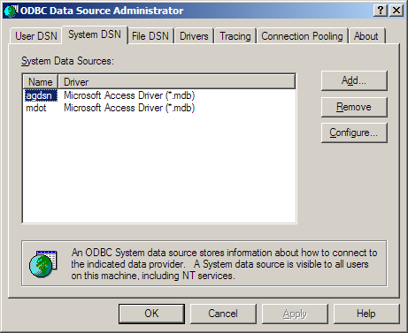
Click the System DSN tab, click Add.
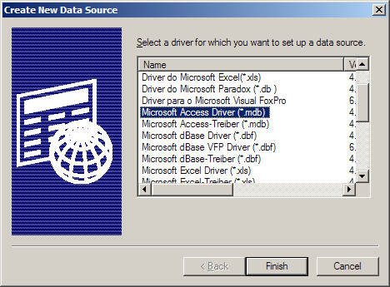
Choose the Microsoft Access Driver. Click Finish.

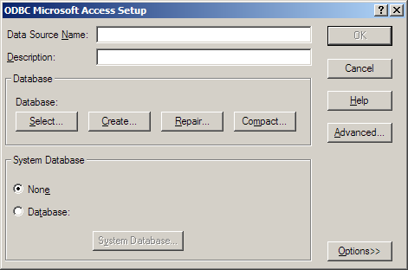
Enter the desired Data Source Name and a description. Then click Select to select the database that you will use with that DSN. In the examples above, agdsn was the AG data source, and mdot was the M-Dot data source. When finished, click ok. Repeat for the other database. When finished, click okay on the main window.

2) Place Equalize in the directory wished. The following files need to be in the same directory:
equalize.exe
eqconfig.exe
3) Create a main data directory for the files that will be converted. This will be the default and may be changed later if need be.

4) Run eqconfig.exe or equalize.exe without an equalize.ini file, this will cause eqconfig.exe to run. If there is no .ini file in the directory, you will be prompted to insert the following values:
The Advanced Geomatics code DSN
The M-DOT code DSN
The default datafile directory
The default delimiter to use for files

If at any time there are values missing from the .ini or the .ini is missing, Equalize will run eqconfig for you to repair the .ini.

5) You are now ready to run Equalize. Just follow the prompts. If your data files are not in the data directory or a subdirectory of it, enter the full path. If they are in a subdirectory, just enter the subdirectory(s) and the file name.

