Table of Contents

- Introduction 02
- Overview 02
- Program Flow 03
- Features 04
- Implementation Details 06
- Difficulties and Improvements 10
- Conclusion 10

Introduction

Before I introduce my project I will introduce myself. My name is TJ Flora, I am a Network Computing major/CIS minor here at Northern. I chose this path for a variety of reasons. Since a young age I have maintained a certain appetite for all manner of games. I have realized this passion as a general interest in systems and I hope to use this to my advantage in my career. I plan to eventually secure a position as a Database Administrator after completing Graduate school in Ohio. Rather than developing production code every day, I would like to work with programmers as a DBA or System Engineer/Administrator. I’ve had two System Administration internships, and they have served to increase my desire to enter the Information Technology field.

The project I have developed is a web crawler written entirely in Java, and tied to a MySQL database. I chose this project not to do something that hasn’t been done before (it has been done many times!), or even do it better, necessarily. I chose it in order to learn about a few specific things. Primarily, I was interested in learning something of writing database-aware Java programs. I was also interested in learning more about networked Java. I also chose Java in particular because I realized that after CS120 I hadn’t used the language heavily in nearly a year. General goals of this project as outlined in the project proposal are reasonable speed, to be as “fair” as possible, and to have some way of making use of the output of the crawler.

Overview

The program is meant to be run as a true web crawler. One runs it through the night, or other such low-use time that you expect the majority of the servers the program will be requesting documents from to be lightly loaded. The crawler must be manually aborted, it will not finish on its own. Even if the crawler somehow managed to visit every URL that it had found, it will continue to wait until it is time to reschedule visits to the already cached documents. Once the user exits the program, it can be run again to work on the data already in the database, it can restart anew, or index the current cached documents. Indexing makes the saved documents “usable.” This is described later.

The program’s general flow of execution is illustrated in the following graphic.

Program Flow of Execution
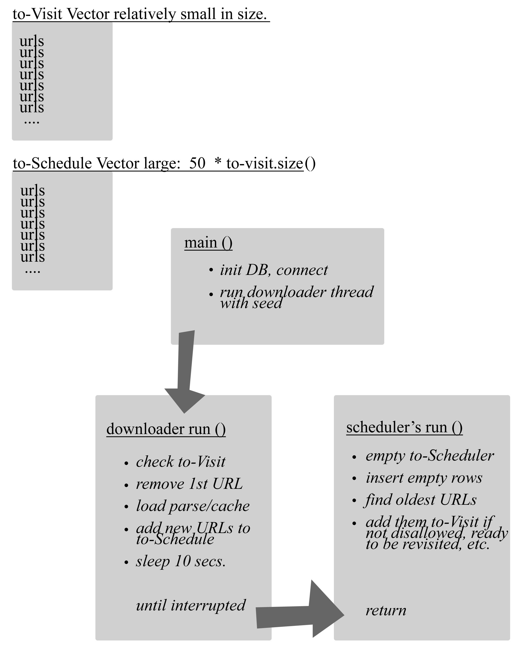

To comment on the above image, the two Vectors store URLs, used in a different way by each thread. Actually, the to-Visit Vector stores a combined URL & bit flag, but that is the only difference other than size. The main method sets up a Database connection, reads command line input, and runs the downloader with (or without, depending on input) seed information. The to-Visit Vector is the downloader’s “Task Pool.” Similarly, to-Schedule is the scheduler’s pool. Once the downloader empties the Vector, it then join()s on the scheduler thread. The scheduler empties it’s own pool by inserting the URLs into the Pages table. It then performs scheduling by filling to-Visit with new URLs and returning. It is safe to say that the crawler will find many links per page, so to-Visit is much smaller in size.

Features

Crawling

The primary feature of this program is that it is a web crawler. This behavior is defined as “a program that automatically traverses the Web's hypertext structure by retrieving a document, and recursively retrieving all documents that are referenced” by robotstxt.org. The crawl itself can easily be broken down into many different tasks and related features, but I will keep each feature’s discussion in it’s own section. Above, you will recall I mentioned two Task Pools. Let’s first look at what happens when the to-Visit pool still contains URLs to be inspected.

The downloader thread first checks to see if anything is available, and if there is, it removes a String representation of a URL and a bit flag from the Vector in the form of a Site object (an encapsulation, that with hindsight should probably be renamed to Page). The Downloader attempts to connect to and download this document. At this point a number of this could have gone wrong. The downloader will wait 20 seconds to get a connection and 30 seconds to complete reading from the InputStream. Since unvisited pages are inserted into the Pages table (albeit with a null source field) and retrieved later, pages might not exist anymore or never have existed at all. The scheduler does a good job of making sure it doesn’t schedule anything in storage that no longer exists, though.

Assuming the page was retrieved successfully, the document’s robots meta tag is examined, this is another feature covered later. In short, if it is not explicitly disallowed by this tag, it will parse the page for links and/or cache the document. When I use the term “cache” I specifically mean that the downloader updates the pages table with the site’s name, current source (minus the tags), last visited time, etc. The crux of parsing for links is this regular expression:

Pattern pttrn = Pattern.compile("<a href\\s?=\\s?\"{1}(.+?)\"{1}.*?>", Pattern.CASE_INSENSITIVE);

and a method that constructs java.net.URL objects in order to test for easy relative URL handling. There is also a method to further normalize the URL. This means that the %-encoded triplets are capitalized and the fragment identifier and default port are removed. The parsing
method finally adds the scrutinized URL String to the to-Visit Vector if it does not already contain it.

Scheduling

There would be no crawling in my program at all without the scheduling thread and the logic behind it. It would be possible to meander through the web, following links page by page, but I chose to insist on securing as many links as possible and eventually visiting them even after consecutive runs. Other goals were to be able to schedule revisits in case of page deletion or updates and to revisit documents based on server response time. In this section I will outline the strategy used by the scheduler to accomplish these goals.

Again, above it is shown that when the to-Visit task pool becomes empty the downloader join()s the scheduler thread, waiting for it to return before continuing. At this point the scheduler removes every URL String and inserts a “blank” record into the Pages table. The URL is scrutinized one more time here for validity by my robots exclusion implementation, more on this later. Most URLs will pass this test and be stored. It then moves on to scheduling more pages to visit.

The to-Visit Vector is divided during scheduling, ¾ of it is devoted to new visits, (i.e. records from the Pages table that have a NULL source), and ¼ is for revisits. I use a size 12 vector, so this allows for 9 new visits and 3 revisits every time schedule is run(). For each revisit, the scheduler constructs a java.util.Date for the future date and time this page should be checked again. This is based solely on the day it was cached and an offset by roughly eight hours for each millisecond it took retrieve the entire document. If at the time this calculated revisit is performed the current day and time is after that, the revisit may be scheduled. It is checked once more by reading the last-modified header from a HEAD request to that URL. If it has been modified since the last visit, it is then finally scheduled.

The normal visitation strategy is much simpler. The program still makes a HEAD request and discovers the last-modified value, but it is simply a test for existence. It is possible, after all, that pages link to documents that no longer exist. If the HTTP response message is not equal to “OK” or it gets no response at all, the scheduler will delete that record from the table and move on. This occurs any time a URL is scheduled.

Exclusions

There are two exclusion standards I tried to follow when writing this crawler. First, and most important, is the robots exclusion standard detailed at robotstxt.org. Briefly, each website may or may not have a text file at http://<authority>/robots.txt that describes what robots may not visit what areas of their site. I ignored the User-agent field, since what is in robots.txt almost always applies to everyone. I placed my implementation inside of a class called robotsExclusion, with an entry method the scheduler uses as mentioned previously. The methodology is to first check the Robots table for the particular site (I use the authority part of the URL), if no entry exists it checks the site for a robots.txt file and then updates the Robots table. It will always return a Boolean indicating whether a particular URL is forbidden based on the applicable robots.txt file.

Another somewhat lesser known standard is the robots meta tag. This is also described at robotstxt.org. It is a last-ditch effort to prevent a crawler from storing or harvesting links at the individual page level. My program does not look to this tag for explicit permission (it isn’t widely used), only for what it is not allowed to do. There are two values in this tag I am interested in, “NOFOLLOW” and “NOINDEX.” If NOFOLLOW is set, the downloader never parses the page for links. If NOINDEX is set, the page is not stored and it’s blank Pages record is deleted so that it is not scheduled again.

Indexing

To index the pages stored, the program needs to be run again with the “index” argument. This will make the database searchable. The program’s strategy for searching is to index the words, and the count of each appearing in the page. It is naïve to assume topical words are repeated multiple times, but it seems to work when not abused by web authors. It is but one criteria more developed search engines use. The indexer works by retrieving the “source” of a Page (actually the source minus most of the tags) and splitting it according to the simple regex: "\\s+". The results are sorted and inserted into the Indexes table along with what page each word occurs in and how many times. When indexing the program does not need to need to be exited by user input, it will finish when it retrieves a page it has already indexed again.

Searching

There is a search available at http://euclid.nmu.edu/~tflora/search/search.php. Written in PHP, it is minimal and really not much to look at. Nevertheless, the search returns relevant pages. It accepts as input any number of words, although it only actually searches on the first three space-separated words. The section on SQL Queries has more to say on this feature.

Implementation Details

MySQL/Java Database Connectivity

To integrate Java with MySQL, one simply needs to import java.sql and add the mysql-connector/j .jar to the Classpath. The JDBC API is meant to allow the programmer to use the same code over multiple Database systems, so the various connectors accomplish the specific translations needed for each platform. From there it is a simple matter to establish a connection to your desired database. This code finds the MySQL JDBC dirver and declares a connection object:
try{
Class.forName("com.mysql.jdbc.Driver");
Connection con = DriverManager.getConnection("jdbc:mysql://localhost:3306/mysql","root", "");}
catch(Exception exc){
System.out.println("Couldn't find the jdbc driver-EXITING");
System.exit(1);}

Once “connected” one can use the same Connection variable throughout the program. Interaction with the database is enabled though Statement and ResultSet objects. There is a 1:1 relationship between Statement objects and ResultSets. As it’s name indicates, a Statement encapsulates a complete SQL statement. Once one invokes a Statement’s execute() function, a ResultSet can be retrieved (or ignored). The ResultSet is used as scrollable access into all of the rows returned by the Statement, if any. ResultSets can also update specific rows, but for the purposes of my project I ignored that functionality. The ResultSet makes it a trivial matter to retrieve data from any SQL data type with a vast number of “getter” methods.

Java.net API

In order to connect to a server and obtain an InputStream, one must include java.net. This provides access to a number of objects for writing networked applications. In this project I used the URL and HTTPURLConnection. The steps to set up a remote connection to a resource are simple. First, one declares a URL object. Then, open the connection by calling the URL’s openConnection() method. At this point I cast the returned URLConnection to a HTTPURLConnection, since I am not at all interested in other protocols. At this point a large number of parameters can be set on the connection. For example, in the downloader code I set these parameters to identify the crawler and myself to the world (I never got any angry emails).

http.setRequestProperty("User-Agent", "WebGetRobot/1.0");
http.setRequestProperty("From", "tflora@nmu.edu");

Once that is done, the connect() method of the HTTPURLConnection is called. Here one can check the values of various header fields via getter methods such as getHeaderField(“key”). Finally, an inputstream can be obtained from the getInputStream of HTTPURLConnection. Reading it is quite simple as well!

int readIn = 0; //read-in byte
int clength = 0; //# chars read
Reader reader = new InputStreamReader(buffer);
while((readIn = reader.read()) != -1 && clength < theLength)
{
readChars[clength] = (char)readIn;
clength++;
}
thewebPage = new String(readChars);
logThis("::Successfully downloaded document @::" + theURL + "::");

MySQL Tables

I’d like to take some time to take about data uses, sources, and table structure. Throughout the project, the tables went through several iterations. As they are now, they are sub-optimal. This is primarily due to the fact that all Primary Keys are defined as Auto-Generate Integers rather than a more useful data type. To find a row, all queries use an index defined on another field. For example, to find a page, the Primary Key is ignored and it searches pages.name, defined as a TEXT type instead. I was able to speed it up by adding extra indexes, but it could be faster with better design in the first place. Following are the tables in my database with descriptions of each following.

Pages
Field | Type | Null | Key | Default | Extra
Id | Int unsigned | N | PRI | NULL | Auto-increment
Name | text | Y | MUL | NULL
Source | text | Y |  | NULL
Title | Varchar(255) | Y |  | NULL
Size | Mediumint  unsigned | Y |  | NULL
Howlong | Smallint unsigned | Y |  | NULL
Visited | Timestamp | Y |  | Current _ Timestamp | On _ Update _ Current _ Timestamp
Indexed | timestamp | Y |  | 0

The pages table is what I am referring to when I write a page is “cached.” Some of it is self evident, but comment is necessary for some of the fields. The Name field is the fully qualified URL of a particular document. There is fixed length, unique index defined on this field. The source is the source of the document without tags. This is stored rather than the entire source document due to the fact that nothing within tags is used for searching and to conserve space. The title is the parsed HTML title, and is stored separately for later display. Size stores the length of the source. Howlong is the duration in milliseconds it took to completely read the document. It is used to adjust later revisit scheduling. Visited is the last time the document was downloaded, and indexed the last time it was (of course) indexed.

Robots
Field | Type | Null | Key | Default | Extra
Id | Int unsigned |  | PRI | NULL | Auto-increment
Authority | text | YES | MUL | NULL
Disallow | text | YES |  | NULL

This table is used by my Robots Exclusion implementation. The Id field hardly needs commenting, but Authority and Disallow may. Authority is the authority part of a URL, for example: “www.nmu.edu.” This is how I identify a particular “site” with forbidden areas. The Disallow field is the accompanying “area” such as “/teamweb” that should not be visited. A 0-length entry means to avoid everything and anything from that authority. An index is defined on the Authority field for faster retrieval

Indexes
Field | Type | Null | Key | Default | Extra
Id | Int unsigned |  | PRI | NULL | Auto_increment
Word | Varchar(50) | YES | MUL | NULL
Url | Text | YES | MUL | NULL
Howmany | int | YES |  | NULL

The indexes table is designed to be a record of every visible “word” on the page, my plan being to achieve topical accuracy on search results with this strategy. The Word field is, of course, an individual word found in a document. I previously spent some time trying to find the longest English word, but for now I am simply keeping it this long just in case. The url is the fully qualified location of the document, same as the Pages.name field above. Howmany is the number of occurrences of “word” at this particular “url.” Custom indexes are defined on word and url for faster searching.

SQL Queries

I would like to compare a query the PHP searching uses to a typical example elsewhere in the program. Most of the queries are select/update statements on one table. For example, this query:

String sql = "SELECT name, visited, howlong FROM webget.pages WHERE source IS NOT NULL ORDER BY visited LIMIT " + ((numQueue * .25) * 2) + ";";

is from the scheduler where it is capturing the names and visited dates for revisitation. This query, however, is much more complicated:

$query = "SELECT a.url, a.howmany, b.url, b.howmany, p.title, p.visited FROM indexes a, indexes b, pages p WHERE a.word = \"$searchWords[0]\" AND b.word = \"$searchWords[1]\" AND a.url = b.url AND p.name = a.url ORDER BY a.howmany DESC LIMIT 30;";

This query is from the two-word search out of the php code. It performs both an outer join (2 tables joined) and an inner join (same table joined) and took some time to develop. I learned quickly that searching functionality can easily escalate into difficult SQL syntax!

Difficulties and Improvements

There were, of course, a number of difficulties and problems that were not evident straight away. The most troublesome problem was writing this as a truly multithreaded application. Up until my first long - term run of the crawler it hadn’t hung up due to deadlock even once. The problem was that I assumed that since Vector was fully synchronized, I would be more or less free of those issues. Definitely not the case! The old structure used both Task Pools like the image above shows, but instead of using join() the threads would wait() and notify() on their respective Vectors. Downloader would wait() on to-Visit when it became empty and notify() on to-Schedule and vice versa. I tried adding synchronized blocks, and using infinite timeouts but it would inevitably hang. Frustrated, I removed that strategy from my design and took the performance hit of allocating a new runnable object every time the to-Visit pool is emptied. Time allowing, I would go back and make this program truly multi-threaded.

There are also other things that I would have liked to see improved. A more robust search and a table redesign would top the list. There could also be an issue of security in my search form. There’s always reason to be suspicious and careful when inserting unknown strings into an SQL query! Searching could be made a great deal faster as well. It is fast enough now, but what about when millions of index entries exist? This would be of great importance to a commercial-level service. Rather than using an outer join on non-key indexed fields, a foreign key/primary key relation between the two would assure fast search times in the long term.

Conclusion

In terms of learning from what I set out to, I believe it has been a worth while venture. This is not only from the perspective of programming skills or knowledge, but self-direction and time management. It has been challenging to work without having someone to tell you what needs to get done, even if it’s just a few times a week. I do feel somewhat disappointed because I could have done more, even though I completed what I sought out to do. I think I deserve at least a B.

B is for Batman.

