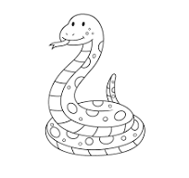
CS 202 Final of the Snake!

0) Is your name on the test?
(a) No because I want to fail the class
(b) No because I have free will
(c) Yes because I’m not a dumb-butt

1) What does this code print?
p = [[“Python”, 1], [“Cobra”, 12], [“Rattle”, 3]]
print(len(p))

2) What does this code print?
p = [“Python”, “Cobra”, “Rattle”]
print(p[0:1])

3) Write some code that sums all the numbers from this list
p = [[“Python”, 1], [“Cobra”, 12], [“Rattle”, 3], ….] # Goes on for a long list of snakes

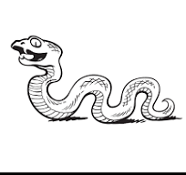
4) What does this print?
p = [[“Python”, 1], [“Cobra”, 12], [“Rattle”, 3]]
p.sort()
print(p)
(a) [[“Python”, 1], [“Cobra”, 12], [“Rattle”, 3]]
(b) [[“Cobra”, 12], [“Python”, 1], [“Rattle”, 3]]
(c) [[“Python”, 1], [“Rattle”, 3], [“Cobra”, 12]]

5) What does this code print?
b = 1
while b > 100:
print(“Python!”)
print(“Cobra”)
6) What does this code print?
b = 1
while b < 100:
print(“Python”)
b = b * 10

7) Write some code that prints “Ball” if the variable ‘length’ is less than 1.0, “Python” if it is between 1.0 and 2.0 inclusive, and “Cobra” if greater than 2.

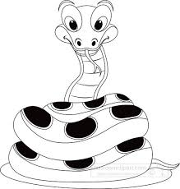
8) What’s wrong with this code? It’s not a typo but something fundamental.
def snake(x):
print(“Python!!!”)
snake(“Cobra”, “Rattle”)

9) Write a function that returns True of the argument is less than 5, and False otherwise. It might be used like this:
ans = thing(3)
print(ans) # should print True
ans = thing(13)
print(ans) # should print False

10) I have many pet snakes. Each snake has an ID code. Each code is exactly two letters followed by one number followed by a ‘0’. Write a regular expression that matches snake IDs.

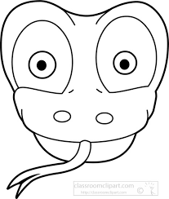
11) What does this code print?
f = open(“a_text_file.txt”, “r”)
f.readlines()
print(f[0])
(a) The first letter in the file
(b) The first word in the file
(c) The first line in the file
(d) The whole file

12,13,14) There is a file called ‘python.txt’. Write some code that makes a new file called ‘cobra.txt’ that is a a copy of ‘python.txt’.

15) What does this code print?
try:
f = open(“Some_file_that_does_not_exist”, “r”)
print(“Python”)
except:
print(“Cobra”)
print(“Rattle”)

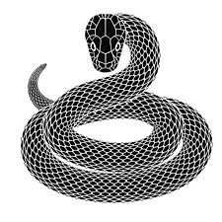
16) Suppose using the library graphics.py I do this. Where is the circle?
C = Circle(Point(30,20), 10)
(a) about upper left corner
(b) about upper right corner
(c) about lower left corner
(d) about lower right corner
(e) about the center

17) What’s the circle’s radius?
10 20 30 40 50 60

18) How does programming make you feel in your heart?

19) What type is the variable ‘thing’?
file = open(“Some file that does exist.txt”, “r”)
for thing in file:
print(thing)

(a) It is either a string or an integer, and depends on what’s in the file
(b) it’s always a string
(c) it’s always an integer
(d) I’m willing to get this question wrong just to let you know how much I hate snakes!

19,20) Write some code that prints the numbers but not the snake name. It must work for any lines with this format, even if the numbers get more or fewer digits or the snake name changes. Hint: Use split
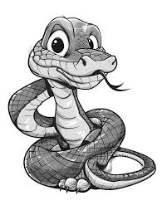
line = “12, Ball Python, 3”

