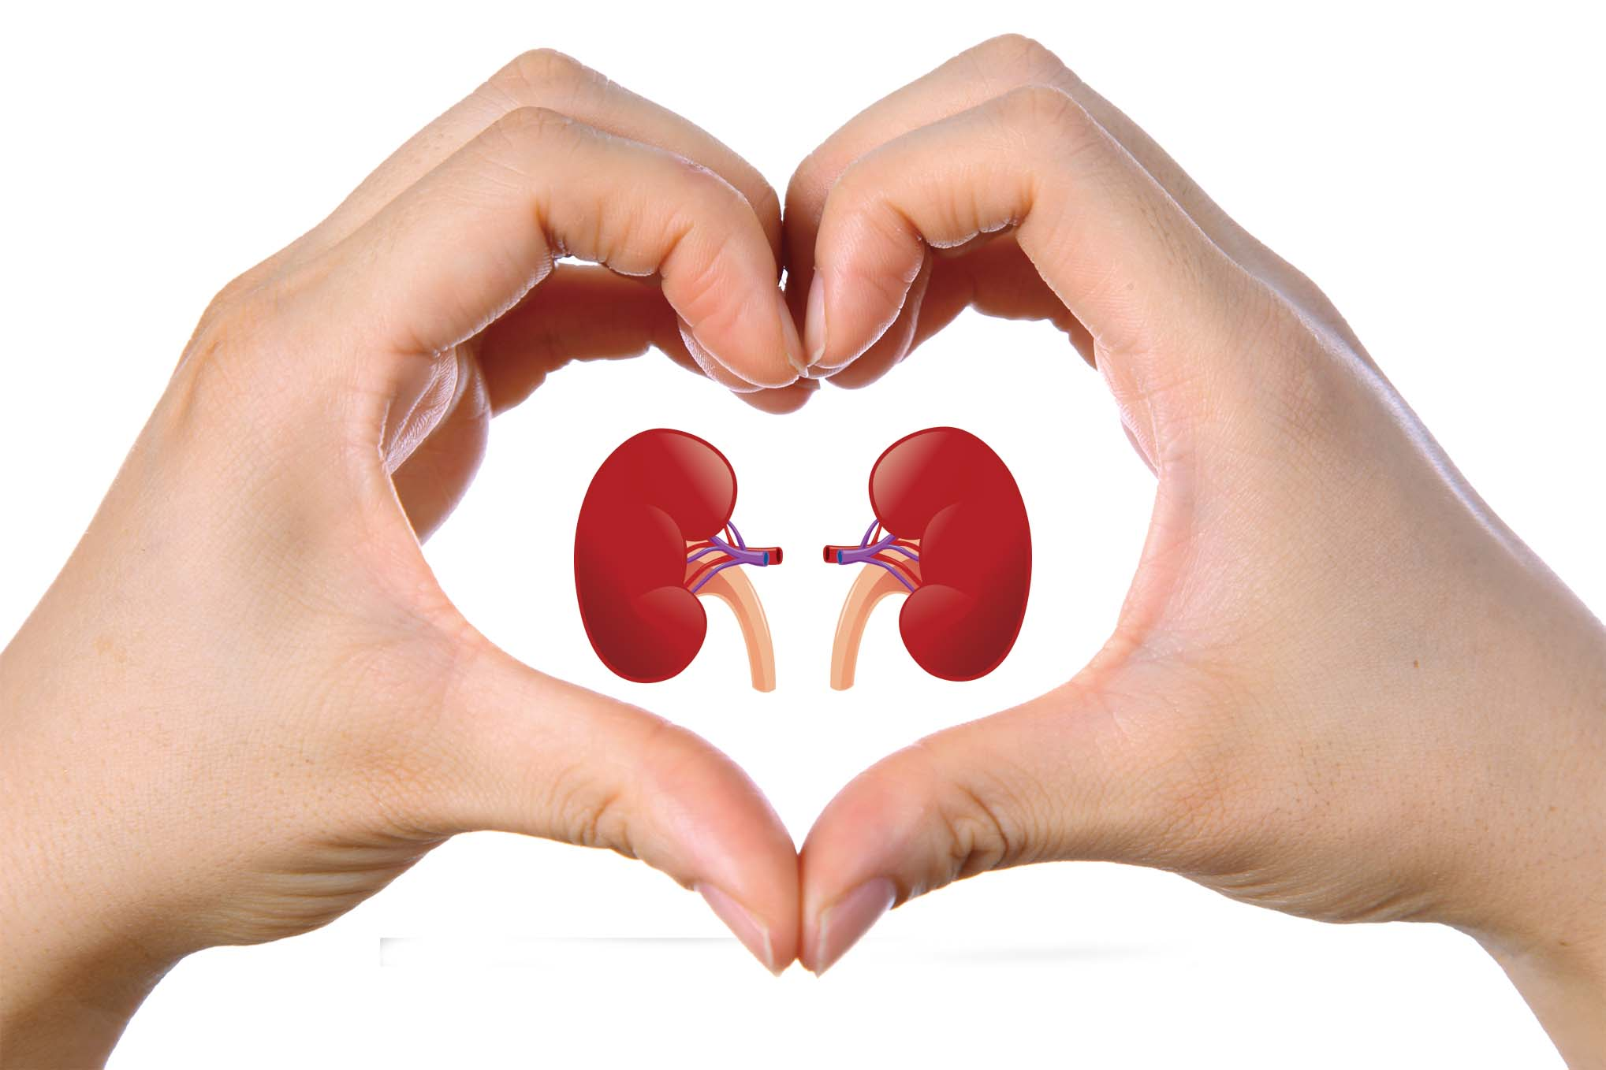
CS 228 Midterm of Organs

Ethernet
1) How many bits in a WiFi MAC address
a) 32
b) 48
c) Wifi does not use MAC addresses
d) some other answer

IP
1) How many IP numbers are there? Be within 10% You can use an easy math formula if you want.

2) If the time-to-live field reaches zero, the router should
a) reset the time to live field.
b) reset the time to live field and notify the sender
c) reduce the timeout value
d) something else

UDP
1) I send two packets using UDP to kidney.com. Which statement(s) are true? Chose zero or more.
a) If the first packet is lost, the second packet will also be lost.
b) If both packets arrive, the first packet will arrive first.
c) There is not situation where exactly one packet will arrive.

2) I want to send a CD of music.
a) Use UDP
b) Use TCP
c) Liver spots

TCP
1) I'm doing sliding window as used by TCP. I send a packet with data 0...1000. I receive an acknowledgement requesting byte 1001. Now I send a packet with bytes 2000...3000. What acknowledgement might I expect to receive?
a) An acknowledgement requesting 1001
b) An acknowledgement requesting 2001
c) An acknowledgement requesting 3001
d) No acknowledgment for this data
d) Something else
2) I open a TCP socket, send the letter 'p' using TCP to a receiver, and close the socket. How many total packets were sent including my packets and the receiver's packets?

Routing
IP Numbers | Path
13.2.5.0/24 | AS1 AS100
13.1.0.0/16 | AS3 AS2 AS55
(600,000 more entries)
1) Suppose our autonomous system has a routing table as shown above. Is this system directly connected to autonomous system 2?
a) Yes, very likely
b) No, probably not
c) There is no reasonable way to tell with this data.

2) (Yes/No) Suppose our autonomous system receives data that there is a path to 13.2.5.0/24 consisting of sending to AS98 with is connected to AS99 which is connected to AS100 which is the final destination.
a) Replace the old path with this new path
b) Keep both paths
c) Something else

Programming
1) My client and server are connected and talking successfully. I kill the server. What will the client receive as a return value from the next read() call?

2) Both the server and the client call read(). What happens next?
a) This is an error, and one of the reads will return an error code.
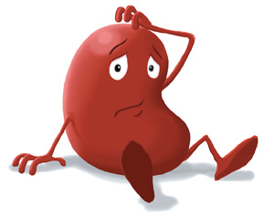
b) This is an error, and both of the reads will return an error code.
c) Something else.

3) What does this program print? Please be careful.
int main() {
int count = 2;
int pid = fork();
if (pid == 0)
count = 3;
cout << count << “ Onions!\n”;
}

DNS
1) Typically, when my laptop wants to convert www.liver.com into an IP number,
a) it contacts the computer with that hostname and asks it for it's IP number
b) it contacts the root DNS server
c) it contacts the 'dot' nameserver
d) it contacts the resolving nameserver who tells it the answer
e) the dhcp server provides DNS hostname to IP number translation services

2) (Yes/No) Can hostnames contain the Chinese characters for liver?

HTTP
1) What is the big improvement between HTTP/1.0 and HTTP/1.1?

2) Suppose I access the URL http://liver.com/lobe.html using HTTP/1.0. What will the first line of the request be?

EMAIL

1) I send email to dr_jack@liver.com. The subject is “Pain” and the body is “It hurts” and the date is “Thu, 17 Mar 2016 15:10:35 -0400”. Ten hours after I send it he boots his laptop and reads it. Which is true.
a) my email server stores it. Later, his laptop uses SMTP to download it from my email server.
b) my email server uses SMTP to send it to his email server, which stores it. Later, his laptop
uses IMAP to download it from his email server.
c) my email server stores it. Later, his laptop uses IMAP to download it from my email server.
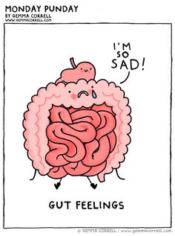
d) my email server uses IMAP to send it to his email server, which stores it. Later, his laptop uses SMTP to download it from his email server.

2) What is the very first byte I send? There are two reasonable choices.

3) In 10 words or less, what is an MX server?

